Providers will need to both add their signature to the document AND update the date.
To Add Signature and Date to the PDF:
- Once the document is open, navigate to the Signature Button in the toolbar.

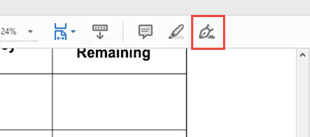

  - If this is not available, it can also be located in the window pane located on the right side of the screen (it may need to be expanded if it’s collapsed by default).

  - Click “Fill & Sign”

- A new task menu will open, at the top of the screen, once “Fill & Sign” or the Signature Button is selected.

- TO ADD YOUR SIGNATURE TO THE DOCUMENT: Click on the “Sign” button and select “Add Signature”

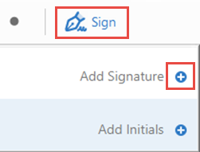

  - If you have a signature on file in Adobe, it will display here instead of seeing the “Add Signature” option, and you may select it. Signature must include your name and credentials.

  - If you do not have a signature on file in Adobe, you have the option to create one:

    - Once “Add Signature” is selected, a new window will open

    - There is the option to type, draw, or import an image of a signature that you may have on file

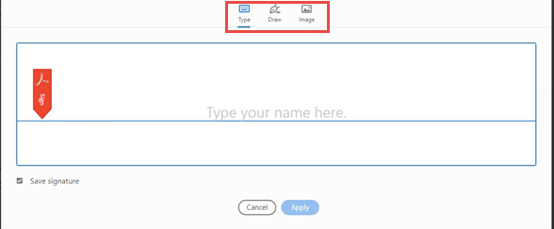

- To retain a signature in the Adobe application for future use, ensure that the “Save Signature” box is selected

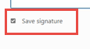
- Once the signature is generated, click “Apply”

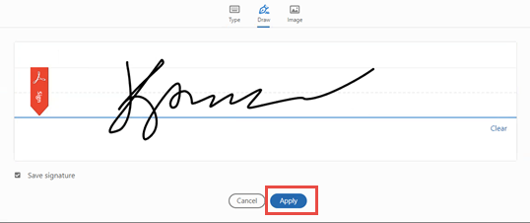

- Once applied, the signature is then available as a movable item, in which it can be moved to any location within the document.

- Place signature in the appropriate location.

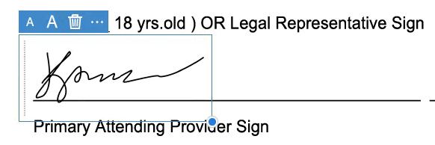

- TO UPDATE DATE AND TIME DOCUMENT HAS BEEN SIGNED: Once the signature is complete, fill in the
“Printed Name” section with the statement “electronically signed by [Name], [Title], [Date].”

  - Click on the document in the appropriate location. Note: you must still have “Fill & Sign” selected for this to work.

  - A text box will appear to add text to the document

  - Complete the name field, as shown below, and all other remaining fields. If another staff has prepared the text box for the signer, change the “Name,” “Title,” and “Date.”

5) Once the document is signed, save the document, and route back to the clinic.

